The Tiesellation Competition

Your challenge is to design a tessellation for use on a tie, or greetings card, or praise postcard. You should produce a few designs and select the one you prefer and then try to produce this using ICT. You could either make your design completely from scratch, or you could make a start by using some of these polygons to see whether they tessellate.
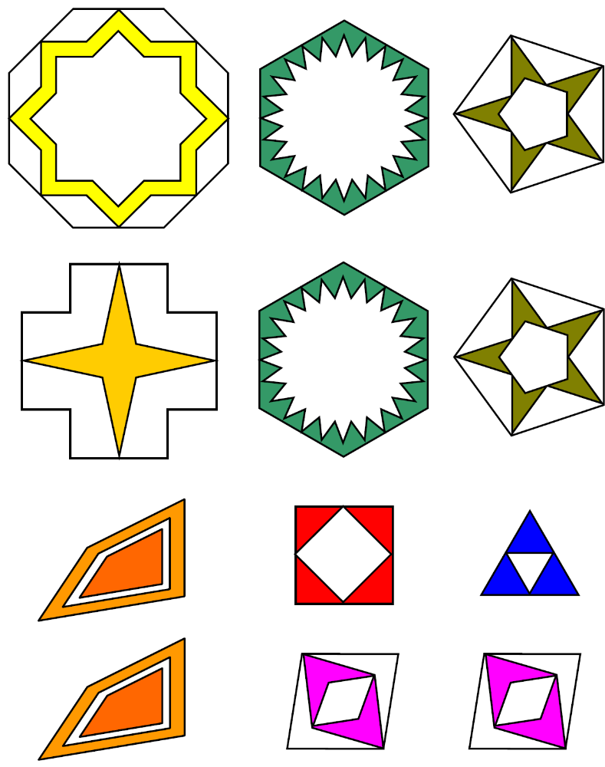

You should produce a poster that explains how you created your design and showing why the pattern tessellates.

